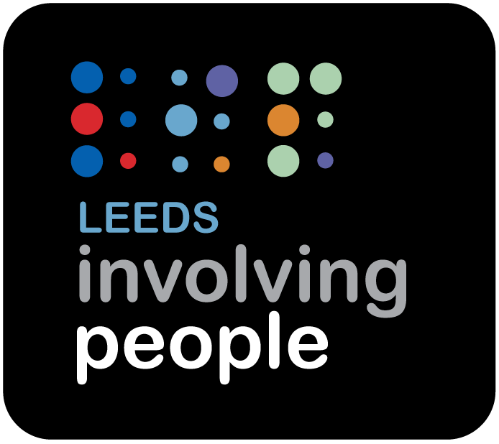

Compliments and Complaints Policy

Contents

1. Introduction 3
2. Making a Complaint 4
3. Complaints Form 6

Introduction

This Policy is to provide the framework for you to tell Leeds Involving People what you think of the service you have received. You may wish to say something positive such as a compliment or to convey a thank you. You may also wish to say something less positive such as a complaint.

Leeds Involving People is committed to ensuring that its work is of the highest quality and always strives to provide the best possible service, but we recognise that occasionally things can go wrong.

We believe that through the effective management and investigation of comments, compliments and complaints we can identify learning to achieve continuous improvement as an organisation.

The following principles underpin Leeds Involving People’s approach to handling comments, compliments and complaints.

- Leeds Involving People recognises that comments, compliments and complaints are an important part of customer feedback underpinned by the following values:.
- The procedure is fair, easy and as transparent as possible.
- The procedure is accessible to all regardless of age, disability, gender, ethnicity, belief or sexual orientation.
- Making a complaint will not harm or prejudice the service that is given to the complainant.
- Concerns and complaints are dealt with efficiently, appropriately and are investigated within the agreed time frame.
- Complainants are treated with respect and courtesy and receive appropriate support throughout the handling of the complaint.
- Complainants receive a timely and appropriate response, identifying the outcome of any investigation.
- Action is taken where necessary in the light of the outcome of the complaint. This might include an explanation or an apology and if relevant and appropriate, information on any action taken.
- It is very important that every effort is made to ensure anyone making a complaint understands the outcome of their complaint.

If you have positive comments about our work or how we have helped you, please email
info@leedsinvolvement.org.uk so we can track that feedback and act on it where necessary.

Making a Complaint

There are three stages that can be used to try to resolve the problem.

Complaints should be addressed to the Chair of the Board of Trustees (marked Private and Confidential), who is ultimately responsible as Chair of the trustees of the organisation.

Stage One (Informal)
- To make an initial complaint (Stage 1), please speak to or email the Finance & HR Manager and we will endeavour to satisfy your complaint and let you know of any remedial action that is to be taken.
- If you don’t know who to contact or do not wish to contact the individual involved, please email info@leedsinvolvement.org.uk.
- All complaints will be acknowledged by the CEO within three working days from the date it is received.
- In order for us to resolve your issue to the best of our ability, please include as much detail as possible regarding your complaint, including any relevant communications or documentation, including dates and times.
- We will respond to Stage 1 complaints within 7 working days.

Stage Two (Formally registering a complaint)
- If you are not satisfied with the response you receive at Stage 1, or you would prefer your complaint to be formally investigated, you can request your complaint to be escalated to Stage 2, either through your contact at Stage 1, or in writing to the CEO.
- You can submit the details of your complaint in-person, during a one-to-one meeting, electronically on the Leeds Involving People website or by emailing the info@leedsinvolvement.org.uk – you should make your email private and confidential with the word Complaint in the subject bar. You can also write your complaint or complete the attached form. The address for written correspondence is: Leeds Involving People, Unit 5, Unity Building 2, 26 Roundhay Road, Leeds LS7 1AB.
- Your complaint will be acknowledged electronically within 3 working days.
- The CEO will investigate your complaint, and you will receive a full written response within 20 working days from the date of the acknowledgement.
- If you are not satisfied with the response to your complaint, you will be given the opportunity to speak to a Director at Leeds Involving People and given the option to appeal (Stage 3).

Stage Three (Appeal)
- To appeal, please outline the reasons for your dissatisfaction in writing or electronically to the Chair of the Board of Trustees.
- This will be the final decision of the complaints process and will ensure the Director has reviewed the investigation, made any further enquiries and then delivers the reason for the final decision.
- The Director will write within 30 working days of receiving the appeal.

Stage 4 (Review of the process)
- If you have exhausted Stages One to Three of the complaints procedure and are not satisfied that we have followed our process properly and dealt with your complaint fairly, you can request a review of the process.
- You can do this in writing or electronically to the Chair of the Board of Trustees, requesting a review of the complaints handling process.
- The decision of the process review will be final. The Chair will communicate in writing within 30 working days of receiving the appeal.

Making a complaint about Leeds Involving People

To make a complaint and to receive a copy of the complaints procedure, find details at http://www.leedsinvolvement.org.uk/contact/.

NB: we aim to respond electronically (which is usually what we mean via “in writing”) however if we do respond via post, we cannot guarantee you will receive a response in the above timeframes due to the current climate.

Complaints Form

- Please read Leeds Involving People’s Compliments and Complaints Policy before completing this form.
- You can ask someone else to help you. You can have a representative or spokesperson.
- You can continue on a separate piece of paper.
- When you have completed the form, please write Confidential on the envelope and send to:
Leeds Involving People – Suite 5
Unity Business Centre 2
26 Roundhay Road
Leeds
LS7 1AB
- You can also find an electronic version of the form at https://www.leedsinvolvingpeople.org.uk/contact or https://forms.office.com/e/i6FjV7rH3P.

Your details

Name
Address
Postcode
Mobile number
Email address

Your complaint

Please describe what you are complaining about. To help us investigate the complaint please give details such as the date, time, place, witnesses and names of people and other agencies involved.

How has this affected you?

What do you want Leeds Involving People to do to resolve your complaint?

Your representative’s details

If you have a representative or a spokesperson who is assisting you, please give their details.

Name
Organisation

Address
Postcode
Mobile number
Email address

Your signature
Print name
Date

Representative’s signature
Print name
Date

Representatives must have the agreement and support of the person making the complaint.

